Labor Law Poster Services

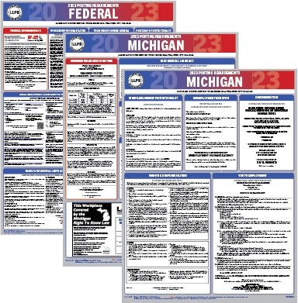

USPS CUSTOMER
BRIEFING

Prepared by Dewane Hall II
US Postal Service Account Manager
dewane.e.hall@usps.gov

Company Overview

Labor Law Poster Service is a full-service company providing required labor requirement posters for businesses across the United States. With over 2 decades of experience, they are confident that their products are accurate and fulfill all of their customer’s business compliance needs. Their staff takes pride in what they do and strive for excellence at every level.

Company Leadership

Joseph Fata
Owner

Thomas Fata
Owner

Michael Bishop
Operations Manager

Justin Fata
VP

Company Biography (Top two Executives)

Company produces and sells laminated posters for labor law requirements.

Corporate Strategies

Corporate strategy is to lower cost and increase brand awareness.

Top Customer Industry or Verticals

Government / Workplace / Posters

USPS Perspective

Shipping:
First Class / Priority

International:
Not at this time

Marketing:
Monthly Mailers via Mail Service Provider

Financials

FY 2023 YTD Revenue November

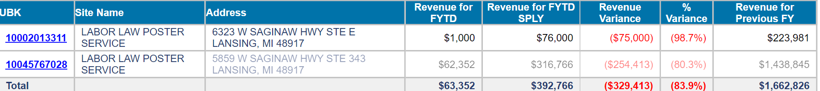

Top Opportunities

Current Negotiated Service Agreement (NSA) Contracts:
Contract Name | Product | Oct YTD 2020 Volume | Commitment | Expiration Date | Status
N/A

Current International Agreements:
Contract Name | Product | Oct YTD 2020 Volume | Commitment | Expiration Date | Status
N/A

Partnering Strategies/Initiatives

Will partner with company to continue learning and uncovering additional opportunity. Will continue to share new and upcoming products and services to help company reduce cost and build brand awareness

Customer Issues and Concerns

No issues or concerns at this time

References

Location:

Labor Law Poster Service
5859 W. Saginaw Hwy. Ste. #343
Lansing, MI 48917
Phone 877-321-4144
Fax 888-442-4144
email cs@llpsinc.com

Main Point of Contact:

Michael Bishop

Sources:

Website-https://www.llpsinc.com/
Facebook
LinkedIn
Twitter

