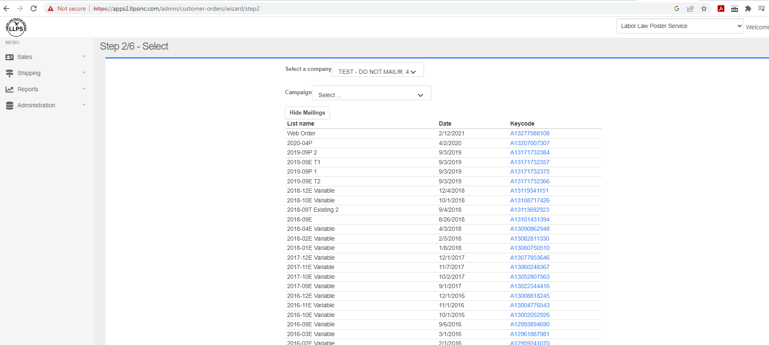
Entered customer ID for mail data order

Then clicked on one of the key codes. Did not go to Step 6 Order Review but said “not authorized”

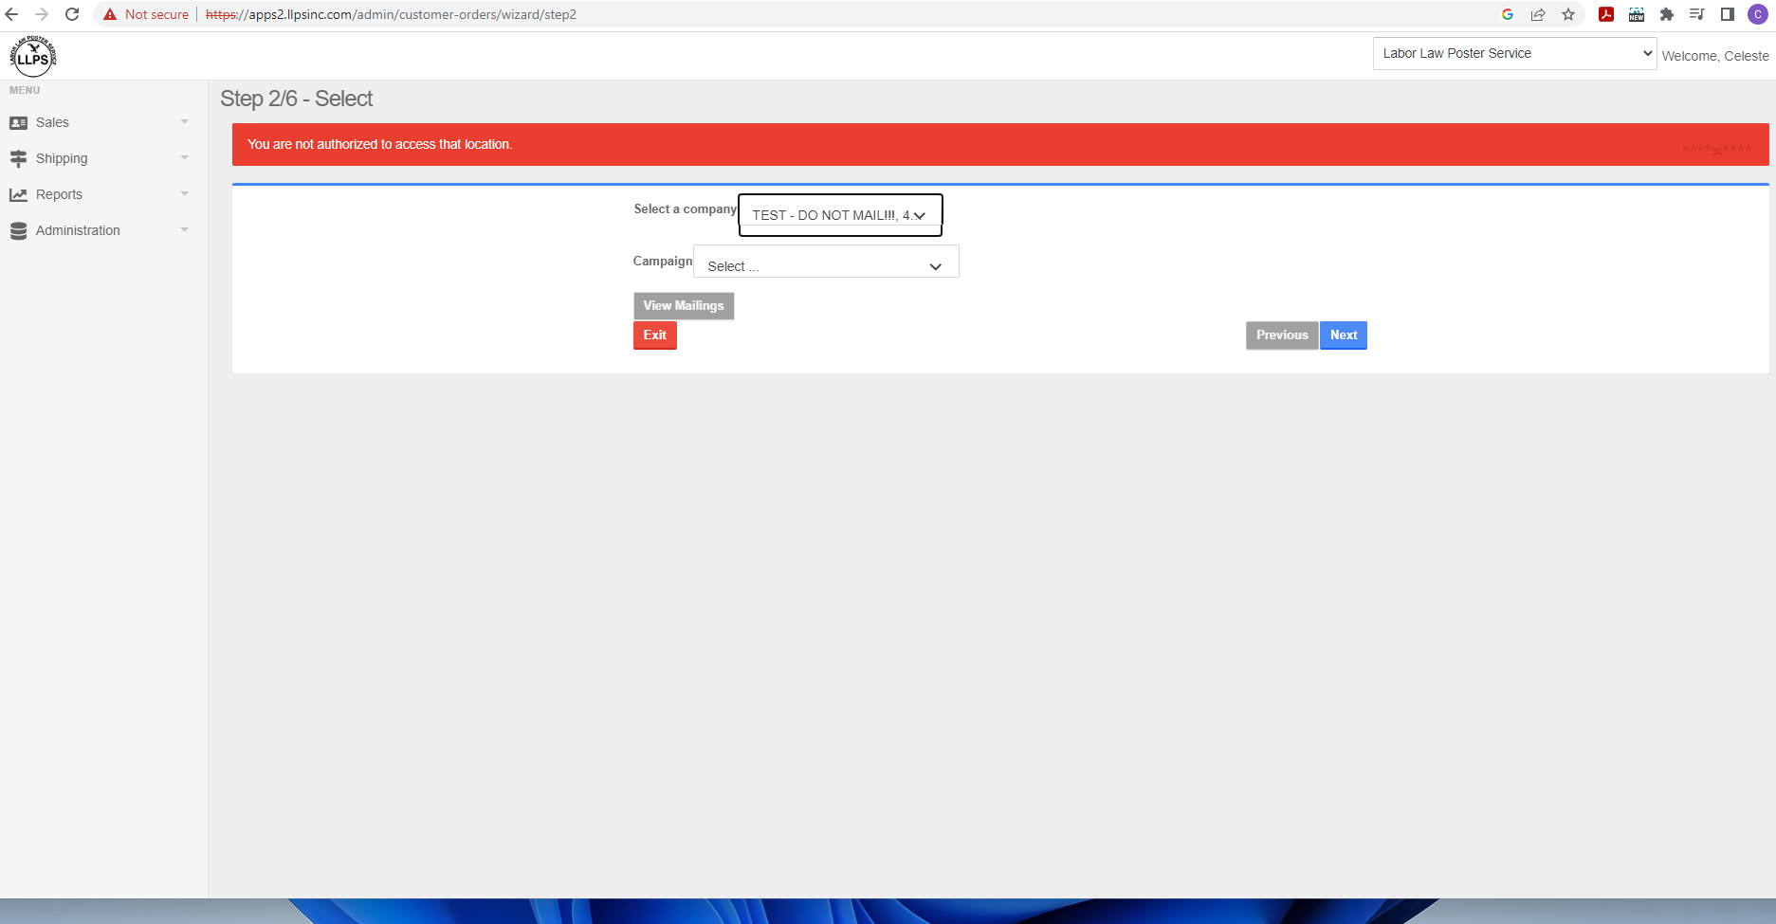

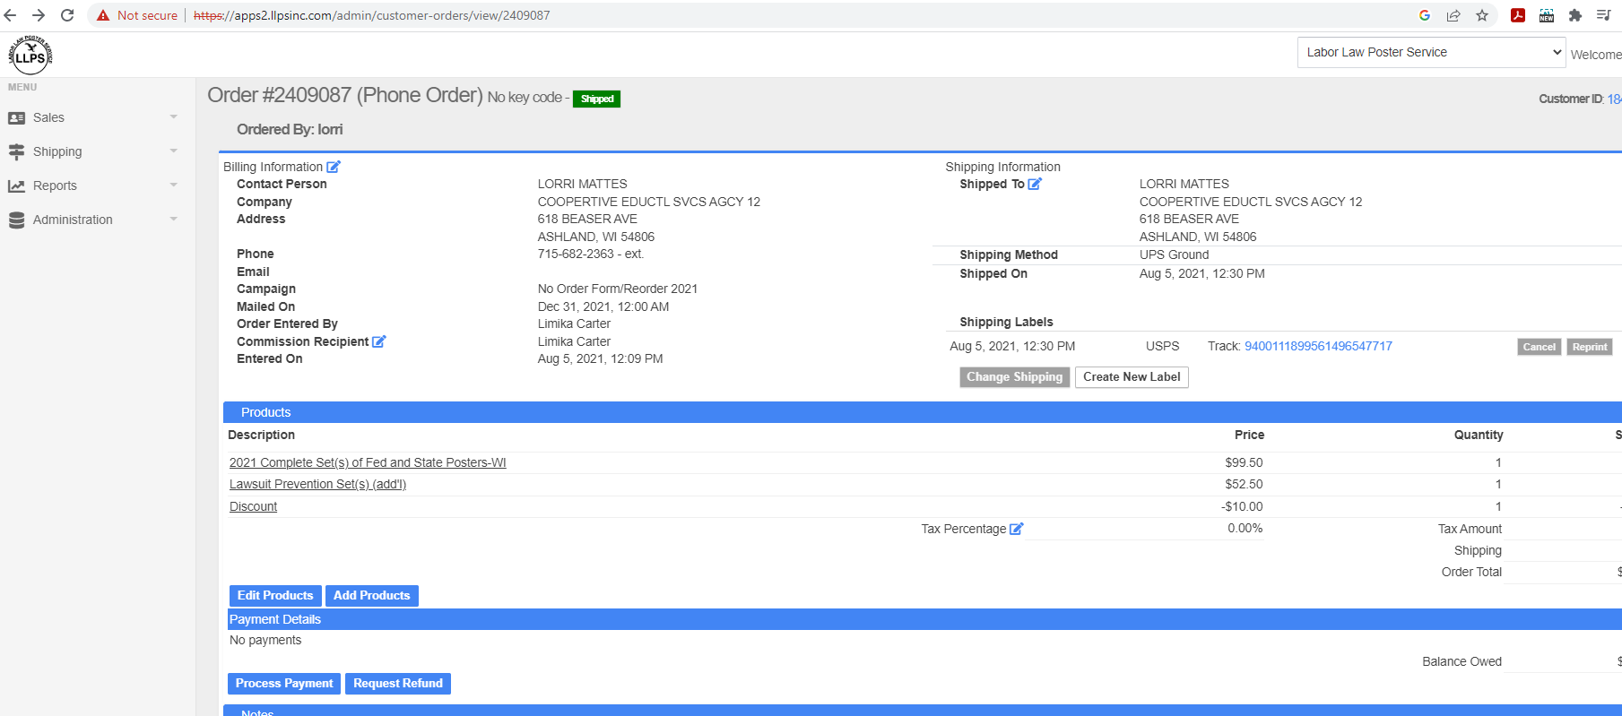
On Company page and chose “View do not contact settings”

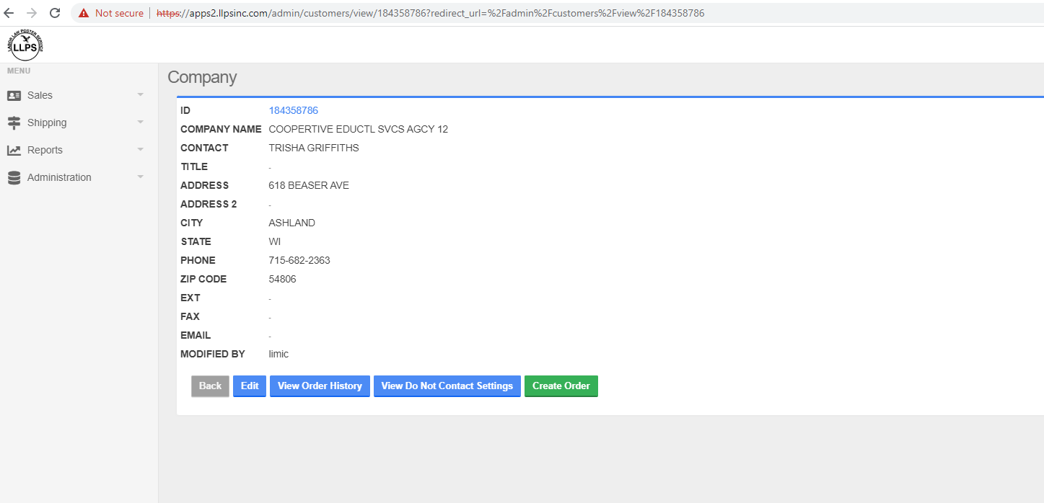
Last updated by


