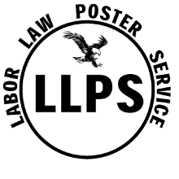
LABOR LAW POSTER SERVICE
5859 W. Saginaw Hwy. #343
Lansing, MI 48917

Phone (877) 321-4144 Fax (888) 442-4144

October 11, 2019

Re: Verification of wages

To Whom It May Concern:

Carlos Mendoza is currently employed with the Labor Law Poster Service as one our Outbound Call Representatives. He is paid $11 per hour and scheduled 40 hours per week. Carlos also is paid a commission on sales made and this amount varies each week. If you have any questions or concerns, please contact me at (517) 321-4144.

Thank you,

Michael Bishop
Operations Manager

