Banking Account Change Request 

Provide your business information
Effective Date
11/28/2018
Merchant ID Number
3892069800015511
Phone Number
(517) 321-4144

Doing Business As Name
Labor Law Poster Service
Legal Business Name
Labor Law Poster Service LLC

Enter your checking account numbers1

Deposit Account

Withdrawal Account

✔Same as deposit account

Where we will deposit your funds.

Provide your current checking account numbers*
Where we will withdraw your fees.

Provide your current checking account numbers*

Routing Number
072413450
Account Number
3036398
Routing Number
Account Number

Provide your new checking account numbers* Provide your new checking account numbers*
Routing Number
072403473
Account Number
01153475824
Routing Number
Account Number
1Only checking accounts can be used. *See next page for instructions on how to locate routing and account numbers.

Select the supporting document you will provide*
Check the box next to the supporting documentation you are supplying and attach it as a second page to this document.

Voided Check Bank Letter
*See next page for examples of documentation requirements.

Acknowledgement
On behalf of the merchant identified above (the “Merchant”), I request that the bank account(s) (the settlement account(s)) associated with the above Merchant ID be updated to reflect the new checking account(s) indicated above (the “New Account(s)”). I represent that I am authorized to submit this change on behalf of the Merchant, and that the New Account(s) belong(s) to Merchant. I authorize you to make any debits or credits to the New Account(s) as may be permitted under my merchant processing relationship with you. I
understand that, if I accept payment types other than Visa, MasterCard and Discover (such as the American Express Card and TeleCheck Services), I am also responsible for contacting the card organizations or companies governing those cards to notify them of this change.

Legal Signer’s Signature

Legal Signer’s Printed Name
Take the next steps to complete the update
Title

Date

- After you complete the form, reply to the email you received from BankAccountChanges@bankofamericamerchant.com. If you do not reply to this email directly, the information will not be sent securely.
- After we receive the form, your request should be completed within 3 business days.
- Keep your existing settlement account open until you confirm funds are deposited into the new account.
- If you are receiving statements directly from a third party providers (e.g. American Express) you must contact them directly to change your account information.

*Voided Check Requirements

Starter checks may not be used.

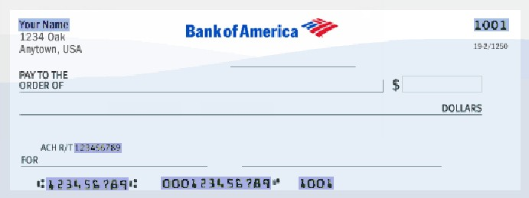 DBA or Legal Name
VOID
ACH Routing/Transit Number
Routing Number
Account Number
The name and address must match the account information on file.

Check Number
Check number must be on the top right and bottom of the check.

The routing number (ABA) must be on the bottom of the check.
The account number (DDA) must be on the bottom of the check.

**Bank Letter Requirements

The bank letter should always be typed.

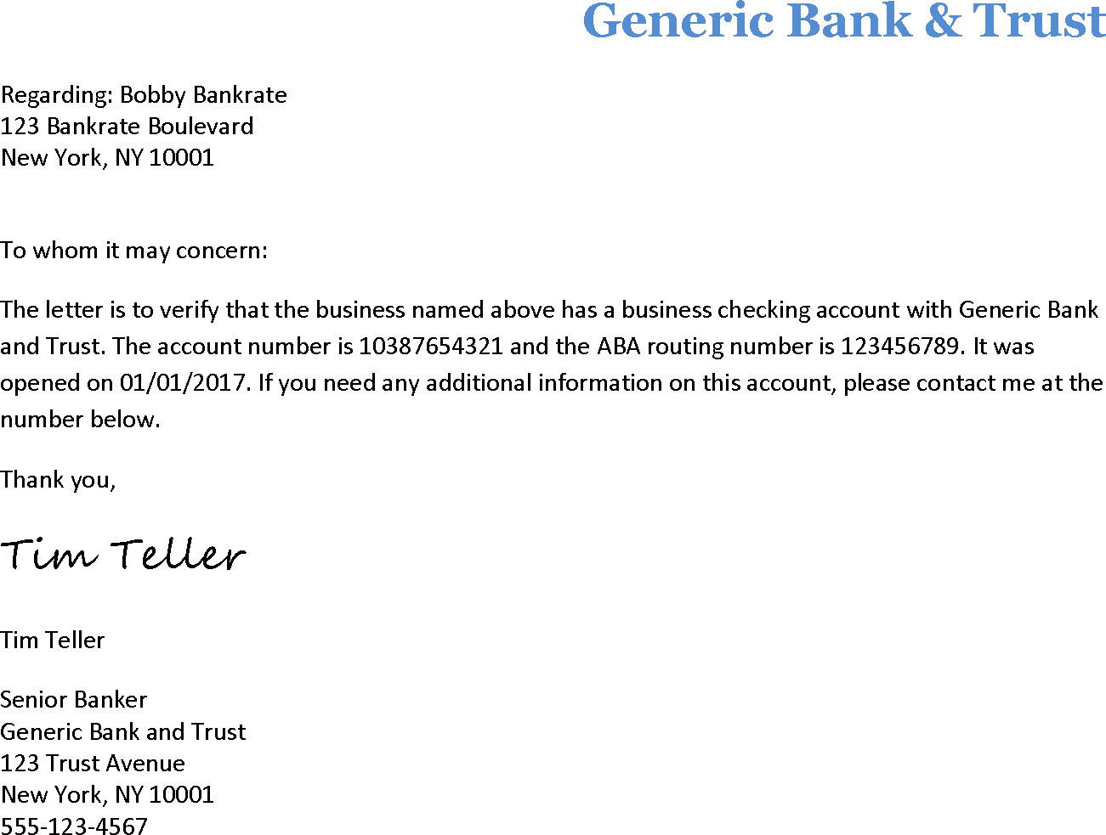
DBA or Legal Name
The doing business as or legal name related to the Merchant ID number should be included in the letter.
Bank Letterhead
The letter must be printed on official bank letterhead.
Banker Signature
The banker should sign the letter.
Routing & Account Number
Ensure complete ABA (routing #) and DDA (account #) is included.
Contact Information
The bank officer’s name and phone number should be included in the letter.

