I AM 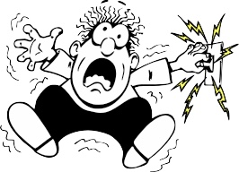SHOCKED!
DO NOT TOUCH ME
BUTT
HELP ME!

