ORDER PLACED
Oct 5, 2024 9:28 PM PST
ORDER # 111-0700511-0650658
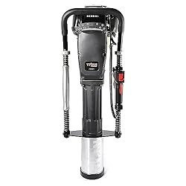
Titan PGD3875, 4" Barrel
Date Shipped: Oct 7, 2024 7:37 AM PST
Order Details
YOUR CONVERSATION WITH

Deerbusters
Oct 15, 2024 1:58 PM
Hello. I purchased this driver, received it Friday, (10/11), and just opened the box yesterday, Monday (10/14). I thought this model would work with the Liftmaster posts I purchased. Upon inspection of the barrel, it looks to be the wrong configuration (no slot on the side). I was planning on buying the adapter piece for this but it shows that it does not work with this model. I would like to return this driver and upgrade to the larger model that has the adapter with it. I didn't add any oil or gas or attempt to start the motor on the driver. I only took it out of the case to see how it lined up against the post. Please let me know if we can do an exchange for the better driver. Thank you.

Oct 15, 2024 2:00 PM
if it has been unused, no gas etc, then yes, you would be able to make a return to our warehouse. The way Amazon works is you would return it and then purchase the new one whenever you wanted. We unfortunately can't apply this purchase towards the new one. You would have to receive a refund.

Oct 15, 2024 2:48 PM
Since the listing is marked as no returns, it will not allow me to make a return. Please advise.

Oct 16, 2024 6:04 AM
Please return the unit to our warehouse
Trident Enterprises
144 Cleveland Ave
Waynesboro PA 17268
if possible, please provide us with a tracking number for the return as soon as possible. I'll make sure this gets refunded correctly.

