Order Details
- Order Number: 6671038443

- Order Date: Friday, November 14, 2025 at 09:57 AM (CST)
- Items shipped (3 items)
SHIPPING TO
Michael Bishop
8607 carlsbad lane,
lansing , MI 48917
517-775-4916

- SHIPPING METHOD
Standard
Product Description | SKU | Quantity | Price | Total
Shipped
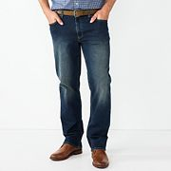  Men's Sonoma Goods For Life® Everyday Relaxed Straight Fit Jeans  - ColorDark Wash  - Size36X34 | 72296035 | 1 | $29.99 | $29.99
Estimated Arrival Wed, Nov 19 2025 to Wed, Nov 19 2025
Tracking#: 1Z4E2R08YW53845164 Packing Slip/Receipt
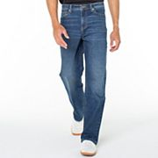  Men's Truth + Triumph Loose Fit Stretch Denim Jeans  - ColorFlint  - Size36X30 | 64407143 | 1 | $24.99 | $24.99
Estimated Arrival Wed, Nov 19 2025 to Wed, Nov 19 2025
Tracking#: 1Z4E2R08YW53845164 Packing Slip/Receipt
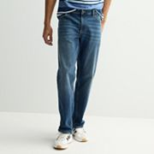  Men's Sonoma Goods For Life® Everyday Relaxed Straight Fit Jeans  - ColorIndigo  - Size36X30 | 60974921 | 1 | $29.99 | $29.99
Estimated Arrival Fri, Nov 21 2025 to Fri, Nov 21 2025
Tracking#: 1Z4E2R08YW53845164 Packing Slip/Receipt

  - BILLED TO
Michael Bishop
8607 Carlsbad LAne,
Lansing, MI 48917
517-321-4144

  - PAYMENT METHOD
Total: -$72.05

- Subtotal:$84.97
Kohl's Cash & Promos:$0.20
SHOPPER20-$0.20
Shipping:FREE
Standard To 48917FREE
Fees & Tax$4.08
Sales Tax$4.08
Total$72.05
YOUR EARNINGS
Kohl's Cash®:
$10.00

to spend 11/21/25 – 11/26/25
Kohl's Rewards: $3.40

added to balance

